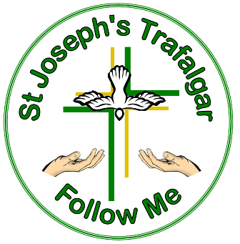
St Joseph’s Primary School Trafalgar

58 Waterloo Road, Trafalgar 3824
Private Bag 3, Trafalgar 3824
ABN 23 218 937 906

Telephone : 03 56331151
Email : office@trafalgar.catholic.edu.au

15 July 2020

Dear Parents, Guardians and Carers

Re: Student Temperature Checks

The Victorian Government announced on 9 July 2020 that daily temperature checks will be introduced for schools in Casey and Cardinia as part of the Victorian Government’s effort to slow the spread of coronavirus (COVID-19). This follows advice from Victoria’s Chief Health Officer. All schools bordering Casey and Cardinia will also require daily temperature checks.

All students in our school will receive a temperature check every morning before attending school, with a non-contact infrared forehead thermometer provided to schools by the Victorian Government.

In order to practically manage this process, we ask that all students enter the school at the front door only.

If a student’s temperature reading is equal to or in excess of 37.5°C the school will implement a process to move the student away from others and conduct a second temperature check 15-minutes after the initial temperature check.

If the second temperature check returns a temperature of 37.4°C or below and the student is not displaying any other coronavirus (COVID-19) symptoms, the student can attend school.

Where a student’s second temperature check returns a temperature equal to or in excess of 37.5°C, the student will be required to remain in a location away from others whilst being appropriately supervised and parent(s), guardian(s) or carer(s) will be contacted to immediately collect their child.

Parents, guardians or carers of students with pre-existing health or medical conditions that result in a temperature being 37.5 °C or above are requested to provide advice to the school from a medical practitioner in relation to the condition and any supports that may be required to assist the school in checking the student’s temperature each school day.

Students who are unwell must not attend school until their symptoms resolve and appropriate medical advice is obtained. This includes those showing even mild symptoms of COVID-19.

The symptoms to watch out for are:
- fever
- chills or sweats
- cough
- sore throat
- shortness of breath
- runny nose
- loss of sense of smell

In certain circumstances headache, muscle soreness, stuffy nose, nausea, vomiting and diarrhea may also be considered.

If students are unwell for an extended period of time, they will be supported in their learning by the school.

Where a student is unwell and absent from school, parents, guardians and carers will not need to provide a medical certificate for their child to return to school.

To ensure physical distancing can be maintained whilst school staff are completing temperature checks, the school will continue to limit the number of students and families congregating on or near school grounds during school drop off times.

If you have any questions in relation to student temperature checks, please do not hesitate to contact me.

Yours sincerely

Patricia Mulqueen
Principal

